## **Track Record**

Kamtech has a vast working experience in **building IT solutions to complex development problems and business issues**. A list of projects and clients for similar services as required for empanelment, indicating description of contract scope, contract duration, contract value, contact references are as follows:

**List of Some Software Clients:**

| **#** | **Client and Contact Details** | **Screen page and URL** |
| --- | --- | --- |
|  | Kamtech in association with SVAP Infotech has developed the Sports tiger app and web portal. The **app has real time data collection and geo location-based monitoring**, which offers stories, live streaming, scorecards and exclusive videos, all at one destination with a swipe.  Features of Sports App:   * 60-Word Latest Sports News. * Stories to be heard are featured right here in a precise format and published in real time. * Live Streaming * Live Scorecards * An in-depth scoreboard to equip you with the real-time highlights.   The technical features are:   * Backend on node JS * angular Backend portal * Mongo DB, Cassandra and Lambda * AWS media services for live streaming * website- PHP | Sports News Live Streaming    <https://www.sportstiger.com/> |
|  | **Zinco India, Alwar**  +91 9414020290  admin@zincoindia.com  zincoindia@gmail.com | <http://zincoindia.com/> |
|  | **Princess Diya Kumari Foundation, Jaipur**  Contact: Shivina Kumari  Email: [shivina@gmail.com](mailto:shivina@gmail.com) | <https://princessdiyakumarifoundation.org/pdkfnew/>  Admin Panel: <https://princessdiyakumarifoundation.org/pdkfnew/admin/login.php> |
|  | **The City Palace Jaipur: Web Portal**   * The City Palace, Jaipur is a palace complex in Jaipur and a world-renowned heritage site. * We developed **Web portal for show case this Palace globally. Summarized completed scope of work is as follows:** * Web Portal (Multi-lingual) with integrated content – city palace branding * Responsive Design website accessible to a wide target audience covering multiple geographical user locations and catering to a large group of users. The Website is compatible with Desktop, Smartphone, iPad & Tablet compatible. * Micro-websites for each property/department based on word press * Dynamic Control Panel * Easy to navigate, attractive design which is fast to download. * Scalable & robust site structure. * Content Editing & collation of content from various sources under client directions. * CMS (Content Management Solution) in the backend we have provided facilities to manage content for modules on news, articles, view registered user’s database, newsletters, announcements, investor presentations, press releases etc. * Proactive Site Maintenance which includes future proofing the site against changes in technology. * SMS and email facilities integration | **www.royaljaipur.in** |
|  | **Princess Diya Kumari**  **MLA Sawai Madhopur**  11, Saket Nagar, Aalenpur Link Road, Sawai Madhopur - 322001 Rajasthan – India  Phone: +91-141-6066607  Email: [socialoutreach@pdkf.org](http://www.investsawaimadhopur.in/Contact.aspx) | www.investsawaimadhopur.in |
|  | **Online Ticket Management System**  **City Palace, Jaipur**  Maharaja Sawai Man Singh Museum II Trust, Jaipur  Contact: Abhishek Pareek  Email: [mgr.it@royaljaipur.in](mailto:mgr.it@royaljaipur.in)  **C:\Users\Vikram\Desktop\kamtech Seal.jpg**  **SIGN** | Ticekting Panel: <https://thecitypalacejaipur.com/book-ticket>  Admin Panel: <https://thecitypalacejaipur.com/ticket> |
|  | **Online Ticket Management System**  **City Palace, Udaipur**  Eternal Mewar, Udaipur  Contact: Shailendra Gupta  Email: shailendra.gupta@eternalmewar.in | Tickeitng Panel: <https://ticket.citypalacemuseum.org/book-ticket>  Admin Panel: <https://ticket.citypalacemuseum.org/ticket> |
|  | [**The Rajasthan Small Industries Corporation Ltd.**](http://www.rajsico.gov.in/)  **Rajasthali (e-commerce web portal and software)**  Udyog Bhawan, Tilak Marg, Jaipur  Phone: 0141 237 2974 | www.pavitram.in/Rajasthali |
|  | **Green Spark Ltd.**  P O Box 54, Cheadle Cheshire  Manchester SK8 4QD United Kingdom  **Telephone** +44-161-4366600 | www.greenspark.co.uk |
|  | **HRG Group –Jaipur**  A4, Near Shubham Tower, Shastri Nagar, Jaipur -302016 (Raj.) INDIA  Tel: [+91-9829058229 | 0141-2280229 | 4049444](tel:9829058229)  Email: [hrgbuildhome@gmail.com](mailto:hrgbuildhome@gmail.com) | SIGNC:\Users\Vikram\Desktop\kamtech Seal.jpgwww.hrggroupindia.com |
|  | **Venus Industries Ltd.**  P O Box 16799, **Dubai - UAE** Tel: +971 4 8816389 Fax: +971 4 8816460 Email: [info@venusind.net](mailto:info@venusind.net) | www.venusind.net |
|  | **Vishwakarma Industries Association**  Jagdish Somani  Association Bhawan,  Road No.1, Vishwakarma Industrial Area,  Jaipur-302013 (India)  Phone : 2331244 | www.vkiassociation.com |
|  | **Golcha Associated Group** Golcha Gardens, Agra Road,  Jaipur 302 003 India  Phone : 141-2640301,  Fax: 141-2640304  E-mail: [sales@golcha.com](mailto:sales@golcha.com) | C:\Users\Vikram\Desktop\kamtech Seal.jpgSIGNwww.golcha.com |
|  | **Industries Department**  **Government of Rajasthan**  DC Gupta  Add. Director ( Cluster)  Udyog Bhawan Tilak Marg Jaipur – 302005  Phone: +91-141-2227161  Email: enquiry@rajcluster.com | [www.rajcluster.com](http://www.rajcluster.com) |
| 11. | **On-Line-Foods**  **Inhouse Site** | **www.on-line-foods.com** |
| 12. | **The Employers’ Association of Rajasthan**  99, Mohan Bari, Galta Road, Near Milieu Field School, Pink City, Jaipur, Rajasthan 302003 |  |
| 13. | **Institute of Leadership Development (ILD)**  **IFCI Institute**  6/2, Jamdoli, Near Keshav Vidyapeeth, Jaipur - 302 031  Phone: 91 141 5184 209, 5184 203,5184222  Email: info@ildindia.org | [www.ildindia.org](http://www.ildindia.org) |
| 14. | **Estate Department -Rajcomp Government of Rajasthan**  Aslam Khan  Nodal Officer – Websites  Tel: 0141-2227678, 0141-2203525  Email: dir-estate-rj@nic.in | estatedeptwww.estate.rajasthan.gov.in |
| 15. | **Trimurty**  **Renowned Builder in Rajasthan**  Sharad Mishra - Director  601, Geeta Enclave, C-Scheme,  Jaipur - 302001, Rajasthan, India  Tel: +91 141 510 7100 | 237 4451  Mobile: +91 9314 407 007  Email: sales@trimurty.com | [www.trimurty.com](http://www.trimurty.com/) |
| 16. | **Asha ka Jharna**  **Prominent NGO in India**  Sudeep Goyal, Secretary  Harlalka Kothi, Nawalgarh - 333042 Rajasthan(India) Phone : +91 1594 223094  Email: info@ashakajharna.org,  sudeepgo@rediffmail.com | [www.ashakajharna.org](http://www.ashakajharna.org) |
| 17. | **Rajasthan Electricity Regulatory Commission**  **Government of Rajasthan**  Commissioner  Vidhyut Viniyamak Bhawan, Sahakar Marg, Near State Motor Garage, Jaipur  Tel: 2741181, 2741016  Email: [rercjpr@yahoo.co.in](mailto:rercjpr@yahoo.co.in) | [www.rerc.rajasthan.gov.in](http://www.rerc.rajasthan.gov.in/) |
| 18. | **Rajasthan Financial Corporation**  **Government of Rajasthan**  Aslam Khan  Nodal Officer – Websites  Tel: **0141-2385522**  C:\Users\Vikram\Desktop\kamtech Seal.jpg**Email:** [info@rfc.rajasthan.gov.in](mailto:info@rfc.rajasthan.gov.in) | SIGNwww.rfc.rajasthan.gov.in |
| 19. | **Tribal Area Development Department**  **Government of Rajasthan**  Aslam Khan  Nodal Officer – Websites  Phone : 0294-2428721/22/23/24  Email: ddit.tad@rajasthan.gov.in | www.tad.rajasthan.gov.in |
| 20. | [**Directorate of Watershed and Soil Conservation, Rajasthan**](http://www.google.co.in/url?sa=t&rct=j&q=&esrc=s&source=web&cd=6&sqi=2&ved=0CFAQFjAF&url=http%3A%2F%2Fwatershed.rajasthan.gov.in%2F&ei=VebgUqn2PIj-rAfYy4H4Dw&usg=AFQjCNG90_W1GPOOWYL8gSQDAAGaolQxCA&bvm=bv.59568121,d.bmk&cad=rja)  **Government of Rajasthan**  Aslam Khan  Nodal Officer – Websites  Phone : 0141-2227477 / 5188155 | watershed[www.watershed.rajasthan.gov.in](http://www.watershed.rajasthan.gov.in) |
| 21. | **Law and Legal Affairs Department- Rajcomp, Government of Rajasthan**  Aslam Khan  Nodal Officer – Websites  Tel: 0141-2227678, 0141-2203525  SIGNC:\Users\Vikram\Desktop\kamtech Seal.jpgEmail: dir-estate-rj@nic.in |  |
| 22. | **Command Area Development, Bikaner**  **Government of Rajasthan**  Commissioner  Tel: 0151 - 2226814 (OFF), O151 - 2226809 (RES.)  Email- dc.cadbikaner@yahoo.co.in | www.cad.rajasthan.gov.in |
| 23. | **Rajasthan Skill and Livelihoods Development Corporation (RMOL)**  *Shri Naveen Sharma*  Manager I & C  Rajasthan Skill and Livelihoods Development Corporation J-8-A, EMI Campus, Jhalana Institutional Area, Jaipur (Raj.)  Ph. 0141- 2705817, 5103248 | www.rajasthanlivelihoods.org |
| 24. | **S. S. Agri Business Pvt. Ltd.**  Kuruda, Balasore, Odisha [INDIA] - 756065  Phone: +91-6782-256063/4  Mobile: +91-9008102834  Email: | www.ssagri.co.in |



SIGN

**Some of our prominent software’s and platforms:**

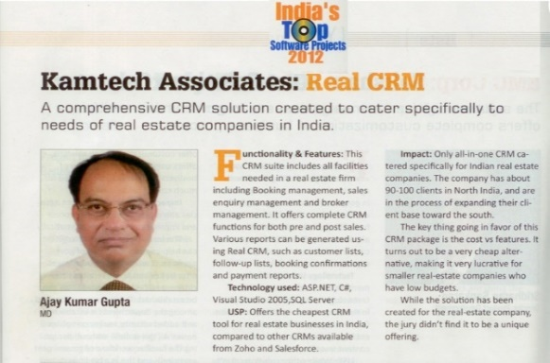**Real CRM (ERP for Real Estate Sector) – Under top 10 Software 2012 in India by PC Quest**

**Clients: 300 Builders and Developers - Working on this software.**

**Real CRM,** which is an extremely powerful yet simply browser based Comprehensive Customer Relationship Management Systems Software. Our team has been given demonstration and we hope that our proposal is under consideration, please mail us for any clarification.

The **Real CRM** is designed keeping in mind the increasing customer’s needs, as customer is the only single most important focus point of this sector and keeping the customer updated from the day when he makes first enquiry till he steps in the flat/ house/plot, is becoming more and more important today for this sector.

This software is a web based, can be assessed by the customer with the convenience of his/her home or office, can be in touch with housing Board virtually all the time getting the information needed.

**Technical Specification**:

* Built on Microsoft Technologies.
* Support Windows 98/2000/XP.
* Front End – .net / Back End – MS SQL Server
* A team of 8 Software Developer’s is consciously doing support and R & D on this system.

As you are aware that Real CRM is software for real estate sector, which is an ongoing business process to focus on gaining, growing and nurturing the right customers for your business. It provides co-ordination between builders, developers, agents and customers at same location or different locations.

Real CRM is user friendly and extremely useful for the growing demand of real estate sector, which needs to have sound customer response and enabling environment for customers to be part of the company from enquiry stage to flat/plot booking and after sales follow-ups, as important part of their business strategy / plan.

**SIGN**It has already been successfully implemented in 300 builders and developers across the India.

**2. Women Empowerment - MIS software Development, survey, and Data Entry (2 Lacs Self Help Groups and 20 lacs members’ data entry)**

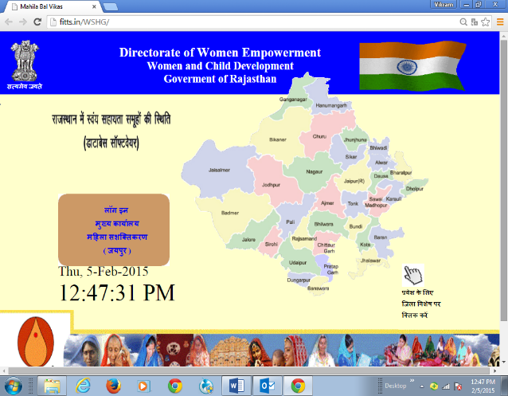 (Client: Department of Women and Child Development, Government of Rajasthan)

We developed comprehensive computerized districts level data base of WSHG’s after actual field survey of 33 Districts of Rajasthan and Prepared MIS software and entered data of **20 lacs women members and 2 lacs WSHG** (125 lacs column entry).

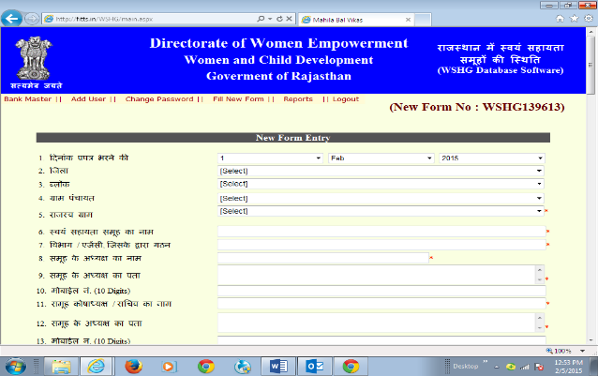The state wise and district wise analysis of the various activities in the report based on the comprehensive data base is helping to the all-stake holder viz. department, NGO’s, micro financing institutions and banks to organize these groups towards more sustainable economic activities.

**Technical Specification**:

* Built on Microsoft Technologies.
* Support Windows 98/2000/XP.
* Front End – .net / Back End – MS SQL Server

**Man Power:** Team Size – 3, Time  **Duration: 2** Months

**3. Work Flow Management System:**

**Features:**

* + Alerts / Notifications
  + Approval Process Control
  + Compliance Management
  + Configurable Workflow
  + Customizable Dashboard
  + Document Management
  + Event Monitoring
  + Forms Management
  + Graphical Workflow Editor
  + Resource Management
  + Cloud Based

It is an ergonomically designed software that enables organization’s team members or employees to receive, process, and respond to allotted assignments viz-a-viz the most precious resource “time”. It is a powerful software that allows breaking of work/assignment in small modules, distribution to respective staff/employees, monitoring, review, coordinate, support to complete the assignment in stipulated time period. As the name suggest, this software smoothens organization work flow.

SIGNEmployees at every level work more efficiently with spending more time on tasks best suited to their individual skill with the use of this software and won’t waste work time for searching documents or supporting material.

**Technical Specification**:

* Built on Microsoft Technologies with the concept of Thin Client and Fat Server
* Support Windows 98/2000/XP and IE 5.0 above
* Front End - ASP.net / Back End – MS SQL Server

**Man Power:** Team Size – 6, Time  **Duration: 6** Months

1. **e-commerce web portal and software**

**Client -** [**The Rajasthan Small Industries Corporation Ltd.**](http://www.rajsico.gov.in/)

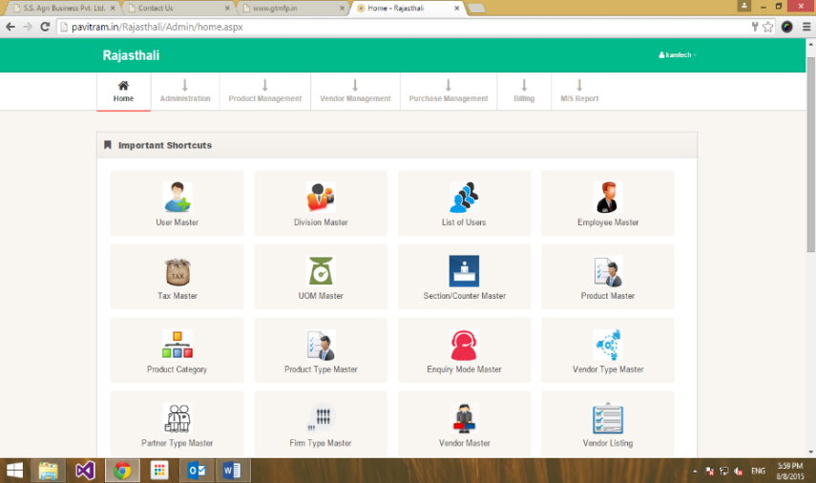**It is an e-commerce Retail Management Information System [SMIS], handling 50 lacs products and sale with Bar Codes.**

SMIS is a robust web-based system built on robust web and intranet technologies with full support and with SMS and email

It creates e-billing integration with payment gateway> It is developed as an exclusively customized billing solution for Service as well as Trading Companies that will cover requirements of small enterprises. It is also linked to the stock analysis and will generate bills and stock report.

Technical Details:

* Built on Microsoft Technologies with the concept of Thin Client and Fat Server.
* ASP.net and Active X Components.
* Supports Windows 9x/NT operating systems running IIS 5.0 and above and IE 5.5 and above.

MIS Reports: 250 Reports

Database: MS SQL Server

**Man Power:** Team Size – 4, **Time Duration:** 3 Months

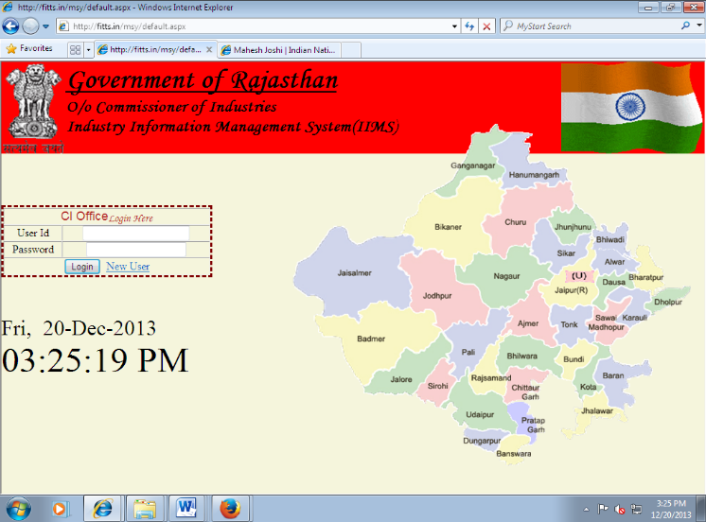

**5. e-governance project for Department of Industries - Government of Rajasthan**

Industry Information Management System Software is a unique online software which can manage Industrial Static Data at each district DIC level. Entire form submission of Entrepreneurs Memorandum M 1 and Entrepreneurs Memorandum EM 2 forms and issuance of certificate can be done online at DIC level and its record can also be viewed at CI Office.

Some features are as follows:

* Entrepreneurs Memorandum EM 1 and EM 2
* UP load Documents on Server in CI panel
* Meeting and Notice Schedule
* Comprehensive Mail Box
* MR 1, MR2, MR3 and MR4
* Schemes and Approval
* Monitoring and Controlling of Chief Minster Self Employment Scheme.

**Technical Specification**:

* Built on Microsoft Technologies.
* Front End – ASP.net / Back End – MS SQL Server

**Man Power:** Team Size – 8, **Time Duration:** 6 Months

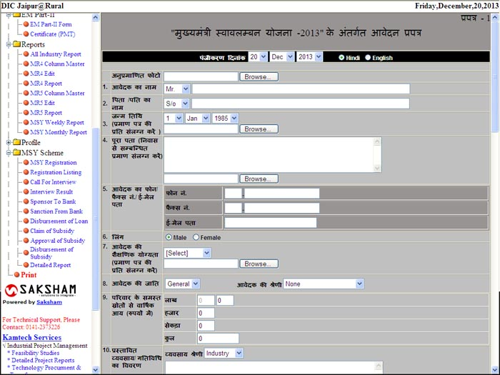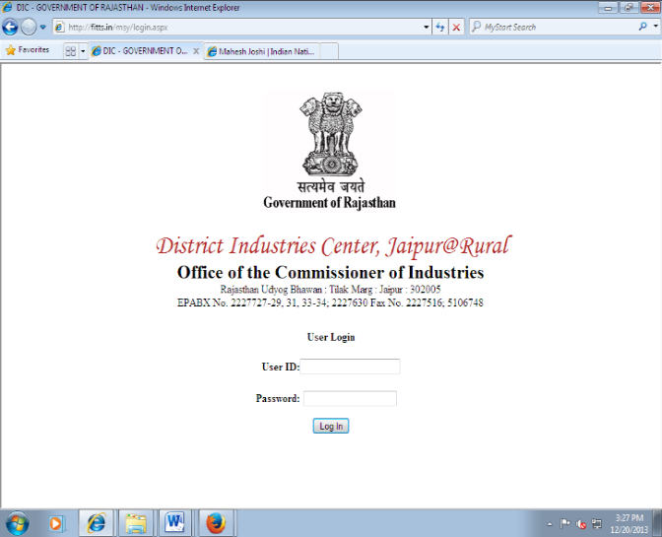

**6. Associated Soapstone Dist. Co. Pvt. Ltd., India**

**Brief of the Client:** Associated Soapstone Dist. Co. Pvt. Ltd. Jaipur is renowned name in the field of soapstone manufacturing in India. The company is having 15 marketing office (branches) across India.

**Scope of Work:** Develop a web based customized ERP solution.

**Our Role**: ASDCappointed us as IT Consultant for the above scope of work. Our work was to prepare IT Road Map and implement the same in various phases.

**Technical Specification**:

1. Built on Microsoft Technologies with the concept of Thin Client and Fat Server
2. Support Windows 98/2000/XP and IE 5.0 above
3. Front End - ASP.net / Back End – MS SQL Server

**Man Power:** Team Size – 8, Time  **Duration:** 9 Months

**7. Pukhraj Gems Export Pvt. Ltd., India**

**Brief of the Client:** Pukhraj Gems Exports Pvt. Ltd. is a Jeweler and exporting silver and gems stones jewellery.

**Scope of Work:** Develop a customized Inventory cum Wastage Management System.

**Our Role**: We developed such kind of solution to manage Raw Material as well as Finished Inventory and also manage the wastage during various processes to make finished goods.

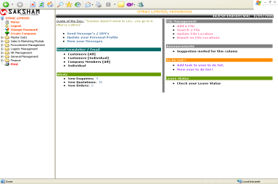**8. Otrac Limited, Hong Kong, PRC**

**Brief of the Client:** Otrac Limited is a Hong Kong based international company and exporting various goods to South Africa Continents.

**Scope of Work:** Develop a web based customized ERP solution which includes Sales, Purchase, Logistic, Human Resource, Inventory and Finance Module.

**Our Role**: We developed such ERP system which suits customer needs and fulfill the requirements.

**Technical Specification**:

1. Built on Microsoft Technologies with the concept of Thin Client and Fat Server
2. Front End - ASP.net / Back End – SQL Server 2000

**Man Power:** Team Size – 10 , **Time Duration: 1.5 Years**

**9. National Small Industries Limited (A Govt. of India Enterprises)**

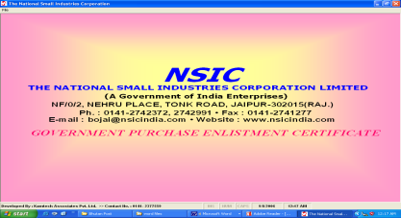**Brief of the Client:** NSIC is a Government of India Enterprises and work for Small Scale Industries.

**Scope of Work:** Develop a customized web application for purchase MIS functions.

**Technical Specification**:

1. Built on Microsoft Technologies.
2. Support Windows 98/2000/XP
3. Front End – Visual Basic / Back End – MS SQL Server

**Man Power:** Team Size - 5

**Time Duration:** Three Month

**10. SAKSHAM ERP – A Business Process Integrator**

Description: logo 3**SAKSHAM** is an effective resource management tool which not only acts as a core Process Integrator of your organizational process but also acts as MIS [Management Information System] for top management, thus acting as a controlling and decision making tool. It leads to Information integration through simple web based customized interface.

One of the most remarkable features of **SAKSHAM** is its process-based approach, each of the modules in the system is studied at client side and best processes and practices are incorporated in the final system.

**Technical Details:** Built on Microsoft Technologies with the concept of Thin Client and Fat Server.

SIGN

SIGN

| **#** | **Name of the Project** | **Client** | **Contract Value** | **Date of start of the work** | **Types of Activities undertaken** | **Date of completion of the Work** | **Reference Contact Details**  **(Name and Address of the Client)** |
| --- | --- | --- | --- | --- | --- | --- | --- |
| **Overall Projects** | | | | | | | |
| **Year 2020-21** | | | | | | | |
|  | Compilation of Data, Analysis, and writing of District Gazetteers of Alwar, Banswara, Jodhpur, Karouli, Hanumangarh  and Pratapgarh districts of Rajasthan | Planning (Man Power) Department, | Rs. 29.75 lacs | 20.02.2020 | To accomplish the task of preparing Gazetteers of Alwar, Banswara, Jodhpur, Karouli, Hanumangarh and Pratapgarh districts of Rajasthan, detailed work flow and services for deployment of experts, qualified and competent resources for preparation of Gazetteers in English and Hindi as per technical specifications for six districts.  Survey in the six districts (Alwar, Banswara, Jodhpur, Karouli, Hanumangarh and Pratapgarh) of Rajasthan and collection, compilation, detailed analysis of the data and prepare the Gazetteers. | On-going | The Director and Joint Secretary,  Planning (Man Power) Department,  Yojana Bhawan, Tilak Marg, Jaipur |
|  | Consultancy Services for (A) Revamping of Particle Board plant at Dala (B) Way forward regarding the RTAF plant at Pasakha | Bhutan Board Products Private Limited, Phuentsholing, Bhutan | Nu 17.50  lacs | 01.02.2020 | Techno commercial assessment of existing Laminated Particle Board unit at Tala, Bhutan in terms of technology upgradation, and Ready to Assemble Furniture unit at Pasakha | 12.07.2020 | Mr. Sangay Wangdi  The Managing Director  Bhutan Board Products Limited  Post Box No. 91, Pheuntsholing,  Bhutan |
|  | Review the resources and prepare a Report on Investment opportunities in the country | Industrial Development Division,  Department of Industry,  Ministry of Economic Affairs | Nu33.50 lacs | 28.01.2020 | To compile resources inventory of Bhutan in terms of investible resources and prepare Country Investment Opportunity report | 30.06.2020 | The Chief Industries Officer,  Industrial Development Division,  Department of Industry,  Ministry of Economic Affairs |
| **Year 2019-20** | | | | | | | |
|  | Study and Preparation of Detailed Project Report for Technical Up Gradation, Automation, Cost Effective Mechanism, Time and Motion Study Related to Production, Submission of New Marketing and Sales System for IMFL, Heritage and Country Liquor. The Bidder will also Submit Project and Its Implementation Plan Regarding Establishment of Gallery Attached with Central Testing Outlet and Restro for Alcoholic Beverages at Jaipur | Rajasthan State Ganganagar Sugar Mills Ltd. | INR 18,40,800 Lacs | 27/12/2019 | * Study and prepare a detailed project report for technical up gradation, automation, cost effective mechanism, time and motion-based men power saving. * Evaluation of marketing and sale system of IMFL, Heritage and country liquor   Feasibility for establishment of central testing outlet, restra and visitor's view for alcoholic beverages. | Ongoing | General Manager  Rajasthan State Ganganagar Sugar Mills Ltd.  4th Floor, Nehru Sahkar Bhawan, Bhawani Singh Road, Jaipur-06.  Tel: 0141-2740841, Web: www.rajexcise.gov.in |
|  | Industry Validation of Existing Qualification Packs Under FICSI | Food Industry Capacity & Skill Initiative  601, 6th Floor, Mercantile House,  Kasturba Gandhi Marg, Connaught Place,  New Delhi | INR 7.80 Lacs | 12/08/2019 | 1. Industry Validation of existing 28 QPs as per NSDC guidelines and up-dation of NOS, if required.  2. Requirement of number of validations for each QP and learning material mentioned in Annexure I  3. Each QP should be validated by 30 Industries for survey (10 Small, 10 Medium, 10 Large enterprise) of major states from relevant food processing sub-sectors.  4. Learning Material – Participant Handbook, Model Curriculum and Facilitator Guide of each QP should be validated by 5 relevant industries from major states  5. The validation should be taken in a prescribed format. The validation also should include suggestions from industry. | 30.11.2019 | Mr. Sunil K. Marwah, CEO  Food Industry Capacity & Skill Initiative  601, 6th Floor, Mercantile House,  Kasturba Gandhi Marg, Connaught Place,  New Delhi- 1100001  Contact No.: 9711260230  Email Id: ceo@ficsi.in |
|  | Preparation of detailed project report for developing the Jaipur ZOO Campus situated at Ramniwas Garden as public Aquarium Galleryon PPP mode | Jaipur Zoo (Wildlife), Jaipur | INR 88,500 | 04/07/2019 | Detailed project report for developing the Jaipur ZOO Campus situated at Ramniwas Garden as public Aquarium Galleryon | 03/08/2019 | Jaipur Zoo (Wildlife), Jaipur |
|  | Providing strategic consultancy to Kirana King Retail Chain (promoted by Dubai based Group) in their business expansion, backward linkages and statutory compliances and business linkages in India. | Kiran King  K-48, Class of Pearl, 4th FL , Geetansh, 49, Tonk Rd, Income Tax Colony, Durgapura, Jaipur, Rajasthan 302018 | INR 25.0 Lacs | March 2019 | Providing strategic consultancy to Kiran King Retail Chain (promoted by Dubai based Group) in their business expansion, backward linkages and statutory compliances and business linkages in India | June 2019 | Mr. Anup  Kiran King  K-48, Class of Pearl, 4th FL , Geetansh, 49, Tonk Rd, Income Tax Colony, Durgapura, Jaipur, Rajasthan 302018 |
|  | Detailed Project Report for setting up a plant of integrated pasta line and fruit dehydration | Agrosafe Idustries Pvt. Ltd.  27, New Khandelwal Nagar  Prem Nagar  Agra Road, Jaipur (Rajasthan) | INR 2.50 Lakhs | April 2019 | We prepared Detailed Project reports of pasta and dehydrated fruit manufacturing plant.  Raw material mapping  • Complete layout designing of processing area, storage, and office.  • Financial Estimation and Projections | August 2019 | Mr. Shubham Khandelwal  Agrosafe Idustries Pvt. Ltd.  27, New Khandelwal Nagar  Prem Nagar  Agra Road, Jaipur (Rajasthan)  Ph. 8560942765 |
|  | Conduction of Research on Demand Aggregation of Manpower for 41  Commission/ Under Implementation/ operational  Mega Food Parks in India | Food Industry Capacity & Skill Initiative  601, 6th Floor, Mercantile House,  Kasturba Gandhi Marg, Connaught Place,  New Delhi | INR 14.50 Lacs | 8/03/2019 | Conduction of Research on Demand Aggregation of Manpower for 41  Commission/ Under Implementation/ operational  Mega Food Parks in India  Raw material mapping  • Supply Gap Manpower Analysis  • HR Forecasting in MFPs  • Detailed report of manufactured products in each MFP & current HR numbers  • Analysis of Skill jobs roles as per QPs, NSQP level of various sub-sectors  • Land allotments and sizes of each MFP  • Training institutes in the vicinity of each MFP for skill development  • Assessment of infrastructure facilities available in each MFP | 20/06/2019 | Mr. Sunil K. Marwah, CEO  Food Industry Capacity & Skill Initiative  601, 6th Floor, Mercantile House,  Kasturba Gandhi Marg, Connaught Place,  New Delhi- 1100001  Contact No.: 9711260230  Email Id: ceo@ficsi.in |
|  | Conducting Study on private part of Education Sector for compiling District Income Estimates 2017-18 | Directorate of Economics and Statistics  Yojna Bhawan, Tilak Marg, Jaipur | INR 6.49 Lacs | 22/05/2019 | Conducting Study on private part of Education Sector for compiling District Income Estimates  2017-18 covering all the districts of Rajasthan for GDP analysis in Private Education Sector | 30/11/2019 | Director & Joint Secretary  Directorate of Economics and Statistics  Yojna Bhawan, Tilak Marg, Jaipur |
|  | Detailed Project Report for setting up a plant of mushroom powder, papad, and cookies | Dekiran Products Pvt. Ltd. | INR 2.00 Lacs | 26/06/2019 | We are preparing Detailed Project reports to set up a manufacturing plant for mushroom powder, papad, and cookies | 30.11.2019 | Mr. Devki Nandan  Director  89-B, Ground Floor, R-Block, Dilshad Garden, Vivek Vihar, East Delhi, Jilmil, New Delhi  +91 9354359209  nimeshshudhankar@gmail.com |
| **Year 2018-19** | | | | | | | |
|  | Provided consultancy to CG Corp (Nepal Based Business conglomerate for Setting up Mega Food Park in Rajasthan and also retail market linkages | CG Group  SEEAI Complex, Surendra Bhawan, Lalitpur 44700, Nepal | INR 32.0 Lakhs | March 2018 | Provided consultancy to CG Corp (Nepal Based Business conglomerate for Setting up Mega Food Park in Rajasthan and also retail market linkages | February 2019 | CG Group  SEEAI Complex, Surendra Bhawan, Lalitpur 44700, Nepal |
|  | Detailed Project Report for Beautification and Development (Water Park/ Tourism etc.) of Teliyon Ka Talab in Municipal Area Tonk | Nagar Parishad, Tonk | INR1.28 | 19/06/2018 | Detailed Project Report for Beatification and Development (Water Park/ Tourism etc.) of Teliyon Ka Talab in Municipal Area Tonk | 18/10/2018 | Mr. Dinesh Goyal  Nagar Parishad, Tonk  Distt. Jaipur, Rajasthan  Ph. No.: 8619580223 |
| **Year 2017-18** | | | | | | | |
|  | Sectorial system of innovation (SSI) survey of the paper and pulp industry in India | UNIDO, Vienna | USD 10,000 | 10/12/2017 | Activity One: Review the data base of actors and addition of data information where missing (size of firm, location, ownership).  Activity Two: Selection of individuals to be trained for data collection.  The sub-activities under activity two to be undertaken are as below:  Suggest number of trainees Provide the CVs of trainees.  Trainees trained by UNIDO expert.  Activity Three: Data collection.  The sub-activities under activity three to be undertaken are as follows:  Data to be collected as per the training on data collection conducted by UNIDO.  Bi-weekly report to be provided to the project manager on actors that have been surveyed. Data to be transcribed into an excel database.  Database to be sent in bi-weekly updates.  Activity Four: Final collation of results. | 08/04/2018 | Mr. Koria Ritin, UNIDO, Austria, Vienna |
|  | Sectorial system of innovation (SSI) survey of the cement industry in India | UNIDO Vienna | USD 12,500 | 10/12/2017 | Activity One: Review the data base of actors and addition of data information where missing (size of firm, location, ownership).  Activity Two: Selection of individuals to be trained for data collection.  The sub-activities under activity two to be undertaken are as below:  • Suggest number of trainees  • Provide the CVs of trainees.  • Trainees trained by UNIDO expert.  Activity Three: Data collection.  The sub-activities under activity three to be undertaken are as follows:  Data to be collected as per the training on data collection conducted by UNIDO.  Bi-weekly report to be provided to the project manager on actors that have been surveyed. Data to be transcribed into an excel database.  Database to be sent in bi-weekly updates.  Activity Four: Final collation of results | 08/05/2018 | Mr. Koria Ritin, UNIDO, Austria, Vienna |
| **Year 2016-17** | | | | | | | |
|  | A Study on Railway Sector for Compiling District Income Estimates | Directorate of Economics & Statistics, Department of Planning, Govt of Rajasthan.  Work Order- 59051/2016 | Rs. 5.46 Lacs | 25/10/2016 | Kamtech has been assigned the study by state Directorate of Economics & Statistics & study is supposed to cover:   * District wise work force of Railway * District wise Gross/Net salary of Railway Employee * District Wise Salary per worker from Railway sector * District wise no of railway stations and track length if available | 28/01/2017 | Rajeev Srivastava  Joint Director  Directorate of Economics and Statistics- Jaipur  Yojana Bhawan, Tilak Marg, Jaipur.  Mob no:9414357991 |
|  | Detailed Report on How to setup new project in Rajasthan: Easy of Doing Business | Rajasthan | Rs. 0.58 Lacs | 19/2/2016 | Detailed Report on Doing Business in Rajasthan Special focus on MSE Sector. It includes various state and Central Government Policy Framework for New projects etc. | 31/03/2016 | The Institute of Company Secretaries of India  Jhalana Institutional Area  Jaipur  Phone 0141-2707236 |
|  | Detailed Report on How to setup new project in Madhya Pradesh: Easy of Doing Business | Madhya Pradesh | Rs. 1.76 Lacs | 22/07/2016 | Detailed Report on Doing Business in Madhya Pradesh Special focus on MSE Sector. It includes various state and Central Government Policy Framework for New projects etc. | 30/09/2016 | The Institute of Company  Secretaries of India – ICSI  22, Institutional Area, Lodhi Road New Delhi – 110003 |
|  | Detailed Report on How to setup new project in Gujarat: Easy of Doing Business | Gujarat | Rs. 1.76 Lacs | 22/07/2016 | Detailed Report on Doing Business in Gujarat Special focus on MSE Sector. It includes various state and Central Government Policy Framework for New projects etc. | 30/09/2016 | The Institute of Company  Secretaries of India – ICSI  22, Institutional Area, Lodhi Road New Delhi – 110003 |
|  | RKCL (Skill and Training Programs)   * Rajasthan Police Academy * Udyog Bhawan * HPCL   Govt. Secretariat | Govt. of Rajasthan  Rajasthan Knowledge Corporation Limited |  |  | We work as Support agency for assessment, implementation and supporting training and skill program all over Rajasthan and Orissa. | Ongoing | RKCL  7A, Jhalana Institutional Area,  Behind RTO, Jaipur-302004  Email: info@rkcl.in  OKCL |
|  | Preparation of Basic Engineering Design Package “Once in a Day Capsule for Anti-Inflammatory, Analgesic arthritis” | National Research Development Corporation (NRDC) | Rs. 2.06 Lacs | 26/02/2016 | We prepared a Detailed Project Report for NRDC. In which we done Design Philosophy as Optimum Capacity, raw material specification, chemical consumption, process building requirement, process description, Block flow Diagram, Process Simulation, Equipment Specification, Layout drawing of plant, P&I Diagram, and Commercial work. | 27/08/2016 | Amitabh Mishra  Manager  National Research Development Corporation  Anusandhan Vikas, 20-22, Zamroodpur Community Centre, Kailash Colony Extn. New Delhi-110048  Ph: +91-11-29240401  Email: write2@nrdc.in |
| **Year 2015-16** | | | | | | | |
|  | Hydrogeological Survey of Dholpani Water Source – Sarpang Bhutan | Bhutan Government  Army Welfare Projects Ltd. | Nu. 25.30 Lacs | 24 /12/2015 | Mapping recharge area of spring water, Mapping geology and geological survey, Drawing geological cross sections  Geological field survey Geophysics Investigation Hydro Geological Study and Performing tracer technique. | 31/03/2016 | Mr. Rinchen Yoezer  Managing Director  Army Welfare Projects Ltd.  00975 -06-252216  Email: yehsey12@gmail.com |
|  | Preparation of Corporate Plan for 2015-2020: Ferro Scrap Nigam Ltd | Ferro Scrap Nigam Ltd  (A Government of India Undertaking)  Equipment Chowk, Central Avenue, Bhilai | Rs. 5.24 Lacs | 19/10/2015 | Past Performance review, SWOT Analysis, Business Scenario & Opportunity for Business development keeping view about the government policies, Suggestion for improving quality & productivity, Performance projection for the period 2015-2020 and MOU rating | 31/03/2016 | Mr. G.C. Naidu (MM)  Ferro Scrap Nigam Ltd  Equipment Chowk Central Avenue, Post Box No 37, Bhilai  Phone: 2222474, 2222475  Fax: 2220423, 2223884  Email: gmmm-fsnl.cg@nic.in |
|  | Appointment as Consultant for updating of Detailed Project Report of Salt Refinery Project of Two Lacs Ton per annum at Nawa Distt. Nagaur (Rajasthan) | Hindustan Salts Limited  PSU | Rs. 2.60 Lacs | 20/11/2015 | General Description, Cost Benefit analysis, details of Machinery and Equipment, Detailed layout of the plant and all requisite structure, Quantity and cost estimates for the work based on Construction drawings. | 20/12/2015 | Rajeev Agnihotri  General Manager  Hindustan Salts Limited  B-427, Pradhan Marg, Malviya Nagar, Post box no. 146, Jaipur-302017  Ph: 0141-2524093  Email: info@indiasalt.com |
|  | Technical Advisor for Kharaghoda Refinery Project | Hindustan Salts Limited  PSU | Rs. 0.50 Lacs | 10/11/2015 | We prepare and finalize of specification of Salt refinery. |  | Rajeev Agnihotri  General Manager  Hindustan Salts Limited  B-427, Pradhan Marg, Malviya Nagar, Post box no. 146, Jaipur-302017  Ph: 0141-2524093  Email: info@indiasalt.com |
| **Year 2014-15** | | | | | | | |
|  | Flatted Factory Complex | Government of Rajasthan | Rs. 0.48 Lacs | 23/12/2014 | DPR for Under Infrastructure Development MSE CDP Scheme. | June 2015 | Mr. A.K. Singh AGM(EIS)  The Rajasthan Small Industries Corporation Limited, Rajasthan Udyog Bhawan, Jaipur: 302005  Mob. : +919414229079  Email: rajsico@rajasthan.gov.in |
|  | Investment & Economic Plan Sawai Madhopur | MLA – Sawai Madhopur | Rs. 1.50 Lacs | 10/04/2014 | Marketing Analysis for Investment Opportunities, Listing of Resources, Labor and Available Skills Requirement Survey, Detailed Investment Plan, Project Profiles, Policy making, Implementation plan. | 18/12/2014 | Mr. Christopher Miller  Special Advisor,  The Royal Family of Jaipur  Rajkumari Diya Kumari,  MLA Sawai Madhopur (RJ)  The City Palace, Jaipur  Mob.:+91 997 108 1665  Email:[cmillerprivate@hotmail.com](mailto:cmillerprivate@hotmail.com) |
|  | Market Feasibility study for Dairy Farm and Fresh milk supply | Jaipur  Prominent Business Group in Rajasthan | 8500 $ | 28/04/2014 | Market Survey among HNI and upper middle-class families in Jaipur. Assessment of customer’s readiness for fresh premium cow milk, existing competitors and customers perception for acceptance of packaging of the milk in PET bottles. Analyzed and prepare a market feasibility report and assessment for the short term, medium term and long-term project growth trend. | 15/09/2014 | Puneet Jain  General Manager  Associated Soapstone Dist.  Co. Pvt. Ltd.  Golcha Gardens, Agra Road, Jaipur – 302001  Email: puneetjain@golcha.com  Web site : www.golcha.com |
|  | Preparation of Basic Engineering Design Package (HIV Drug) | NRDC | Rs. 2.02 Lacs | 28/11/2014 | We prepared a Detailed Project Report on HIV drug. In which we done Design Philosophy as Optimum Capacity, raw material specification, chemical consumption, process building requirement, process description, Block flow Diagram, Process Simulation, Equipment Specification, Layout drawing of plant, P&I Diagram, and Commercial work. | 19/12/2014 | S K Gupta  Sr. Manager  National Research Development Corporation  Anusandhan Vikas, 20-22, Zamroodpur Community Centre, Kailash Colony Extn. New Delhi-110048  Ph: +91-11-29240401  Email: write2@nrdc.in |
| **Year 2013-14** | | | | | | | |
|  | Appointment of consultant for preliminary study and submission of comprehensive report for Haulage of salt by Mechanical means at Gudha, Nawa, and Sambhar lake area in phase manner | Hindustan Salts Limited  PSU | Rs. 3.20 Lacs | 4/07/2013 | Study of existing procedure of haulage of salt, assessment of mechanization, economic handling, layout and drawing, list of suppliers, drawings, preparation of tender document, capital cost estimates. | 4/10/2013 | Mr. SK Bansal  CMD, Hindustan Salt Ltd.  B-427, Pradhan Marg  Malviya Nagar, Jaipur  Phone: +91-141-2524093  Fax: +91-141-2521998  E-mail: info@indiansalt.com |
|  | DPR for Nawa Salt Refinery – Capacity Two lakh TPA | Rajasthan  PSU | Rs. 4.75 Lacs | 4/07/ 2013 | Tender Documents and  Detailed Project Report, Site Selection, Process Evaluation & Design, Procurement Plan, Environment Engineering, Energy Conservation. Market Survey, Financial Estimates | 31/10/2013 | Mr. SK Bansal  CMD, Hindustan Salt Ltd.  B-427, Pradhan Marg  Malviya Nagar, Jaipur  Phone: +91-141-2524093  Fax: +91-141-2521998  E-mail: info@indiansalt.com |
|  | Appointment of consultant for Preparation of detailed procurement specification for new salt refinery with synchronization with existing refinery | Hindustan Salts Limited  PSU | Rs. 1.78 Lacs | 18/12/2013 | Preparation of detailed procurement specification for new salt refinery with synchronization with existing refinery, vendor clarification regarding technical specifications, Technical evaluation and vendor selection, Phasing of retro fitment. | 28/02/2013 | Rajeev Agnihotri  General Manager  Hindustan Salts Limited  B-427, Pradhan Marg, Malviya Nagar, Post box no. 146, Jaipur-302017  Ph: 0141-2524093  Email: info@indiasalt.com |
|  | Professional consultant De-desertification & Green Belts | IRDC  Iraq | 16000 $ | 6/02/2013 | We prepared Detailed project reports, Market surveys, and Detailed feasibility study. | 5/03/2013 | Ridha Salih  Ideal for Research and Consultancy Iraq Tel #: +964 1 5419902. |
|  | Solar Seminar for RKVY | Govt. of Rajasthan | Rs. 0.45 Lacs | 13/08/2013 | We represent Data compilation, Translation and analysis work in front of Rajasthan Horticulture Development Society in a Seminar of Solar. | 10/11/2013 | Anuragh Bhatnagar  Joint Director  Rajasthan Horticulture Development Society  Jaipur |
|  | Mosaic Tiles Plant – JK Cement | J K Cement  221, Ashok Nagar  Udaipur  0294-2412107 | Rs. 2.00 Lacs | 17/07/2013 | Detailed Market Survey and Demand Analysis, Production Data of Tiles, Industries Analysis in This Sector – Gujarat and Rest or India. Project Report, Plant Design, Detailed Plan & Layouts, Construction Layouts, Green Belt Development, Planning & Construction of Production House. | 30/07/2013 | Mr. R. N. Chakravarti  Sr. Vice President  J K Cement  221, Ashok Nagar, Udaipur  Tel: 0294-2412107  rn.chakravarti@jkcement.com |
|  | Project Report on Handloom and Khadi Plaza | Government of Rajasthan | 9972 $ | 27/06/2013 | Survey of 1500 SHG in Seven Districts under Handloom and Textiles sector. Handloom Scenario in Rajasthan State Government Policy, Production Process, Economic condition of Weavers in the Cluster, SWOT Analysis, Available Infrastructure, Expected Outcomes from Development of Cluster, Action plan.  Report approved by GOI & Fund released. Jaipur, Ajmer, Jodhpur, Bhratpur, Churu, Bhilwara, Alwar | 31/12/2013 | Industries Department  Udyog Bhawan,  Tilak Marg, C Scheme Jaipur |
| **Year 2012-13** | | | | | | | |
|  | Bearing Study & Market Survey – 13 Countries | Saudi Arabia, and 13 MENA countries | Rs. 15.35 Lacs | 22/03/2012 | Marketing Analysis of Production and Demand in 13 Middle East and North African MENA Countries. Bearing Market Assessment & Bearing Demand Assessment. Sector wise demand Assessment – Automobile, Engineering, Infrastructure, Railway, Agriculture, Aerospace, Thermal Power etc. | 25/09/2013 | Mr. Khalid Al Sulaimani  CEO-President & Board member  Rajhi Heavy Industries Co. Beautat Business Park # 23, Corner King Road, Jeddha Saudi Arabia  Telephone: +966 1 4601555  Email - [info@al-rajhi.com](mailto:info@al-rajhi.com) |
|  | Preparation of Detailed Project Report and Land allotment for Gabon Wooden SEZ | Associated Soapstone Distributing Company Pvt. Ltd. | Rs. 4 Lacs | 2/04/2012 | We prepared a Detailed Project Report in Which we focused on Business environment of Gabon, Exploitation of Timber, Forest site selection, Costing of Timber etc. | 2/10/2012 | Ranjan Baid  Sr. Manager (Commercial)  Associated Soapstone Distributing Company Pvt. Ltd.  Golcha Gardens, Agra Road, Jaipur-302003  Mob: +91-9352541071  Email: rajanbaid@golcha.com |
|  | DPR of BEDP of Anti HIV Drug | NRDC  New Delhi | Rs. 3.97 Lacs | 27/02/2012 | BEDP of Anti-HIV Drug  Detailed Project Report, Market Assessment, Financial Analysis, Technology Analysis.  We prepared these reports:   * Liquid Bio Fertilizers * Mosquito Larvicidal Formulation Based on Bacillus Thuringiensis Var. Israelensis | 27/08/2012 | National Research Development Corporation  20-22, Zamroodhpur Community Centre Kailash Colony Extension New Delhi - 110048 |
|  | Field Survey and Market Study for Green Tech Mega Food Park – Rajasthan | IL&FS  2nd Floor Niryat Bhawan, Rao Tula Marg, Opp. Army Hospital, New Delhi -110057 | Rs. 6.00 Lacs | 20/11/ 2012 | We completed detailed field Survey and Market Study for agricultural, horticulture, spices and other crops data. Analysis of secondary level data. | 18/02/2013 | Mr. A K Krishnakumar  Executive Director  ILFS, India  Tel: 911146002200  email: info@ ilfsclusters.com  www.ilfsclusters.com |
|  | Dedicated Consultant  Urban Development, Housing & Local Self Government | Urban Development, Housing & Local Self Government  & Jaipur Development Authority | Rs.30.00 lacs | 1/08/12 | Consultant for Township, Survey and Infrastructure Projects, Detailed Industrial Units Planning, Layout, Soil Testing, Market Survey, Procurement plan, including warehouse and Cold Storages need assessment. | 25/10/2014 | Nawal Kishore Bairwa  Dy. Commissioner, Zone 2  Jaipur Development Authority  m-9829577015  Email: dinessharmaca10@yahoo.com |
|  | Providing support as Knowledge Partner for Auto Fair 2013 | Rajasthan Automobile Dealers Association | Rs. 1.11 Lacs | 8/10/2012 | We designed and arranged the concurrent technical sessions, invited industry experts. We designed and maintained auto fair portal, documentation support | Feb 2013 | Naresh Singhal  The Rajasthan Automobiles Dealers Association  3, Agrawal College Bhawan, Maharaja Agrasen Marg,  Agra Road, Jaipur  Ph: 0141-4030400  Mob: 9829017753 |
| **Year 2011-12** | | | | | | | |
|  | Preparation of Preliminary Project Report in accordance with guidelines for Government Departments for e-Governance initiatives for Computerization | Govt. of Rajasthan | Rs. 0.48 Lacs | 9/12/2011 | We implement the Single Window Clearance Mechanism for Investment Proposals for the Rajasthan State and make it functional for the office of Commissioner of Industries and all the 35 Districts Industries Centers. | 31/12/2011 | Rajhans Upadhyaya  Commissioners, Industries Rajasthan, Jaipur  Udyog Bhawan, Tilak Marg, Jaipur-302005 |
|  | Preparation of Basic Engineering Design Package | National Research Development Corporation | Rs. 1.98 Lacs | 21/03/2011 | We designed philosophy of Optimum capacity, Basis of operation, process description, Block flow Diagram, time cycle of each operation, equipment list, list of instruments with specifications, P&I Diagram | 21/05/2011 | Mukund Mehta, Manager  National Research Development Corporation  Anusandhan Vikas, 20-22, Zamroodpur Community Centre, s Kailash Colony Extension, New Delhi-110048  Ph: 011-29240401  Email: mmehta@nrdc.in |
|  | Technical Evaluation/ compatibility of all plant and machineries and evaluation of quality of stage wise product and civil works at Gudha Salt refinery | Sambhar Slats Limited | Rs. 2.50 Lacs | 27/08/2011 | We prepared tender documents of SSL, and Detailed project report. | 12/11/2011 | Sambhar Salts Limited  B-427, Pradhan Marg, Malviya Nagar, PB. 146, Jaipur-302017  Ph: 2524093  Email: hindsalt@datainfosys.net |
|  | Integrated Industrial Park - RSIC | Rajasthan Small Scale Corporation  Government of Rajasthan  Jaipur | Rs.5.00 lacs | 13/02/11 | Detailed Survey of Industries, Transportation Vehicles, Tender Specifications, Layouts&3D Drawings, Detailed Civil & Electrical Estimates. Project Costing Environment Clearance and other Approvals Project Costing Environment Clearance and Other Approvals | 15/04/2011 | Mr. A.K. Singh AGM(EIS)  The Rajasthan Small Industries Corporation Limited, Rajasthan Udyog Bhawan: Tilak Marg:  Jaipur: 302005  Mob. : +919414229079  Email: rajsico@rajasthan.gov.in |
| **Year 2010-11** | | | | | | | |
|  | Proposal for turnkey consultancy for setting fortified flour mill of 10 tons per day capacity at Junjhunu | Shakti Food Industries | 2% of Project Cost | 21/09/2010 | Prepared Detailed Project Reports, offers form plant and machineries manufacturers, preparation of documentations for term loan from bank, consultancy support for industrial plant, site supervision, quality approval and compliances | 20/11/2010 | Shakti Food Industries  Rani sati Road, Junjhunu  Mob: 9829227413 |
|  | Women Self Help Group Survey of Rajasthan  F13(WE)/  WSHG/DFID  MIS/08-09/6761 | Rajasthan  All 33 Districts of Rajasthan  Including Village level. | Rs32.00 lacs | 18/03/2010 | WSHG Data Base with Bank Loan Details. Survey of 33 Districts of Rajasthan (242 Tehsil) and data collection and Data entry in Online Software of 2 lacs WSHG in Rajasthan. | 5/04/2012 | Commissioner,  WCD -  Government of Rajasthan  2, Jalpath, Gandhi Nagar, Jaipur |
|  | Preparation of Detailed Project Report of Rural Warehousing planning | Rajasthan State Warehousing Corporation | Rs. 2.00 Lacs | 12/4/2010 | We prepared detailed project report for Godown Construction work at 7 Place Ajmer, Goluwala, Pdampur, Sangaria, Aanta, Bhratpur, Dausa | 30/4/2010 | Financial Advisor  Rajasthan State Warehousing Corporation  Bhawani Singh Road, Jaipur-302015  Ph: 2565087, 2565088 |
| **Year 2009-10** | | | | | | | |
|  | Organizing the event as Event Manager on Behalf of RajCOMP | Govt. of Rajasthan |  | 24/12/2009 | We organized the workshop of 2 days for “**ICT in education for Girls”.** | 23/02/2010 | Ashwini Kumar Sharma  Managing Director  RajCOMP  C-Block, 1st Floor, Yojana Bhawan, Tilak Marg, C-Scheme, Jaipur-302005  Ph: 0141-2229394, 2228701  Email: info@rajcomp.net |
|  | Agri-Foods Processing Industries Policy VISION-2015 | Department of Industries, Government of Rajasthan, | Rs. 2.75 Lacs | 09/01/2009 | Detailed Survey of Rajasthan Agriculture & Horticulture data, Market Study of mandies in Rajasthan includes Agro resources, crops and Agro Processing Industries and Submission of Policy Vision Document | 20/02/2009 | Department of Industries, Government of Rajasthan, Udhyog Bhawan, Tilak Marg, Jaipur. |
|  | Proposed Inland Container Depot at Bikaner | Rajasthan Small Scale Corporation  Government of Rajasthan  Jaipur | Rs. 13.35 Lacs | 30/10/2009 | Turnkey Consultancy Services, Plan, Develop, Set up, Layouts&3D Drawings, Detailed Civil & Electrical Estimates. Set up and Supervise the Construction work. Project Costing Environment Clearance and other Approvals Project Costing. | 09/03/2011 | Mr. A.K. Singh AGM(EIS)  The Rajasthan Small Industries Corporation Limited, Rajasthan Udyog Bhawan: Tilak Marg:  Jaipur: 302005  Mob. : +919414229079  Email: rajsico@rajasthan.gov.in |
|  | Market Assessment and Demand Analysis on Pre-Fabricated Components. | J K Cement  221, Ashok Nagar  Udaipur  0294-2412107 | Rs. 8.26 Lacs | 29/8/ 2009 | Detailed Marketing Survey in NCR and Rajasthan for Demand Assessment of  On Pre cast hollow core slab and Ready to use Plaster.  We surveyed Builders and Developers, Architects, Civil Engineers, Structural Consultants and Users for Demand Assessment. We provide technology Transfer Assistance for Provide the Technology from Germany. | 10/12/2009 | Mr. R. N. Chakravarti  Sr. Vice President  JK Cement  221, Ashok Nagar, Udaipur  Tel.: 0294-2412107  Email: rn.chakravarti@jkcement.com |
|  | Revival Plan of Rajasthan Handloom Development Co. Ltd. | Rajasthan  Rajasthan Government | Rs. 0.50 Lacs | 15/07/2009 | Report approved by Govt. Future Steps by the Corporation (post Revival) Impact after Revival Plan Implementation Financial Projections After Implementation of Revival Plan. | 15/08/2009 | Mr. Nayab Khan  Chief General Manager  Rajasthan State Handloom Development Corporation Ltd.  Tel: + 2371109, 2361533  Mob.: +919413339068  Email: [sales@rshdc.com](mailto:sales@rshdc.com) |
|  | Making a New Incentive Scheme (including review of existing scheme) to suit our requirements | Wires and Fabriks Limited | Rs. 0.82 Lacs | 20/06/2009 | Policy meeting with HR management, work visits to understand Work Flow, Productivity Data Collection, Mapping of proposed scheme, finalization of Incentive Scheme, Recommendation Implementations | 20/07/2009 | Govind sharma  Asst. Vice President-HRD  Wires & Fabriks  Industrial Area, Jhotwara, Jaipur-302012  Ph: 2341722  Email: enquiry@wirefabrik.com |
|  | Appointment as advisors and accountants | Colored Rocks | Rs. 2.00 Lacs | 15/06/2009 | We prepared all relevant documents and operating business plan as per FDI guidelines and getting the necessary approvals for starting 100% foreign company | 20/06/2010 | Steve Bennett  Managing Director  Colored Rocks |
|  | Proposal for exploring new Green Field Cement Plant in Kenya | JK Cement Ltd. | Rs. 7.00 Lacs | 7/02/2009 | Marketing Survey of Kenya, Uganda and Tanzania for set up of a Cement Plant in Kenya. We conducted cement consumption, demand and collection of geological data, Lime Stone deposit, Demand & Supply and Production Data. Availability of Skilled and unskilled Labor. , | 5/07/2009 | Mr. R. N. Chakravarti  Sr. Vice President  J K Cement  221, Ashok Nagar, Udaipur  Tel: 0294-2412107  [rn.chakravarti@jkcement.com](mailto:rn.chakravarti@jkcement.com) |
| **Year 2008-09** | | | | | | | |
|  | Preparation of DPR for the Proposed packaging Drinking Water project at Jhotwara Distillery | Rajasthan State Ganganagar Sugar Mills Limited | Rs. 0.42 Lacs | 26/04/2008 | Prepared DPR along with Cost Benefit for proposed packaged drinking water project at Jhotwara Distillery | 18/05/2008 | General Manager  Rajasthan State Ganganagar Sugar Mills Ltd.  4th Floor, Nehru Sahkar Bhawan, Bhawani Singh Road, Jaipur-302006s |
|  | Human Resource surveys for BPO | Genpact Limited  JLN Malviya Marg  Jaipur | Rs. 0.90 Lacs | 12/09/2008 | Human Resource surveys for BPO working conditions. Final report Submitted & Approved. | 08/11/2008 | Mr. Hemant Kumar  Project Manage  Tel.: +911413052411  Email: hemantkumar3@genpact.com |
|  | Survey and analysis of Natural Gas consumption – Jaipur | Feedback Venture, Hyderabad  No. 9, 3rd floor, central Plaza, Somaji Guda , Hyderabad | Rs. 1.00 Lacs | 26/08/2008 | Survey for Energy Requirement in Industries and Home Consummation in Jaipur and analysis of Natural Gas.  Final report Submitted & Approved | 25/10/2008 | Mr. Rakesh Jain  [Associate Director](https://www.linkedin.com/title/associate-director?trk=mprofile_title)  Feedback Venture  Tel: +91 124 416 9100  Mob.: +919346486534  Email: rakesh.jain@feedbackinfra.com |
|  | Market Study of Agriculture and Horticulture- Assam | National Institute of Agriculture Marketing  (NIAM)  Tonk Road – Jaipur | Rs. 1.70 Lacs | 19/11/2008 | Market Study of Agriculture and Horticulture- Assam | 05/01/2009 | Dr. Hema Yadav Dy. Director  Ch. Charan Singh National Institute of Agricultural Marketing Bambala, Kota Road, Jaipur  Tel: 0141-2770027.  Fax: 0141-2771938, 2770027  Email: yadav.hema@gmail.com |
|  | Cement Based Products | J K Cement  221, Ashok Nagar  Udaipur  0294-2412107 | Rs. 9.50 Lacs | 17/04/2008 | We prepared detailed Project Report for cement-based products covering Mozaic Tiles, Ready Mix Plaster, Typical Moulded items i.e. Cement chairs, Hollow Bricks, Pavement Blocks | 09/09/2008 | Mr. R. N. Chakravarti  Sr. Vice President  JK Cement  221, Ashok Nagar, Udaipur  Tel.: 0294-2412107  Email: rn.chakravarti@jkcement.com |
|  | Proposal for Preparation of DPR and Presentation for your IT/ITES project coming up at Mahindra SEZ for submission to STPI for unit approval | Nucleus Softwares Exports Ltd. | Rs. 0.60 Lacs | 14/05/2008 | We prepared DPR and Presentation for your IT/ITES project coming up at Mahindra SEZ for submission to STPI for unit approval | 20/05/2008 | Poonam  Company Secretary  Nucleus Software Exports  Ltd.  A-39, Sector-62, Noida-201307  Tel: +91-120-4031400 |
|  | Proposal for Bankable DPR for Organic Farming, processing and retail marketing project to be set up in Jaipur | Nature Bounty Dairy Limited | Rs. 0.50 Lacs | 23/02/2008 | We prepared Detailed Project reports of Organic farming, green house-based horticulture products and farm level collection, cleaning and gardening, processing, packaging and retailing through established chains and later on through own franchise stores. | 23/04/2008 | Mr. Hitesh Jaju  Nature Bounty Dairy Limited  New Delhi |
|  | Consultancy offer for preparation of DPR setting up of Jute Park | Rajasthan Jute Fab Park Private Limited | Rs. 0.55 Lacs | 18/01/2008 | We prepared a detailed project report covering five units for various types of Jute bags, Carpets and rugs, Jute yarn and Clothes for home furnishing | 18/02/2008 | The Chief Executive officers  Rajasthan Jute Fab Park Private Limited  Swasthay Kalyan Bhawan  Near Trimurti Circle,  Jaipur-302004 |
| **Year 2007-08** | | | | | | | |
|  | Preparation of Detailed Project Report for Jaipur Agro Food Park as per the MOFPI Scheme | Jaipur Agro Food Park | Rs. 2.00 Lacs | 16/08/2007 | Compilation and Collecting Data, Raw Materials, backward, Supply Chain issue, Cold chain issues from farmers collections, preparation of all cost estimates of site development, physical infrastructure, and prepared the DPR as per guidelines of MOFPI | 15/10/2007 | Shyam B. Agarwal  Chief Executive Officer  Jaipur Agro Food Park  Swasthya Kalyan Bhawan, Narayan Singh Road, Near Trimurti Circle, Jaipur-302004  Ph: 0141-2573935  Email: jagrofood@gmail.com |
|  | Providing the Services for Rajasthan Mission on Livelihoods for One Year | Bhartiya Samruddhi Investments & Consulting Services Ltd. | Rs. 0.30 Lacs | 1/04/2007 | We studied on three Agro processing products and its potential. Study assignment as undertake study of Aronla, Ashwagandha and Aloe Vera, Present status of Rajasthan, Further needs to be done for promoting these products in the state. | 30/04/2007 | Rajeev Kumar Gupta  Program Manager  UNDP project  Bhartiya Samruddhi Investments & Consulting Services Ltd.  H.O. surabhi Arcade. 3rd Floor, Troop Bazar, Bank Street, Koti, Hyderabad-500001  Ph: 040-30512500  Email: info@basixindia.com |
| **Year 2006-07** | | | | | | | |
|  | Short Term Skill Training programme for Livelihood under Rajasthan Mission for Livelihoods | Govt. of Rajasthan | Rs. 0.54 Lacs | 16/11/2006 | We provided a training of DTP operator and certificate to all trainees | 22/12/2006 | Entrepreneurship & Management Development Institute  J-8A, Jhalana Institutional Area, Jaipur-302004  Tel: +91-141-2705541, 2705542  Email: emi_jaipur@yahoo.com |
|  | Investment Opportunities Studies – Bhutan Country Report | Department of Industry,  Ministries of Trade & Industry  Bhutan | NU.26.00 lacs | 03/01/2006 | Surveyed all 20 Dzonkhas (Districts) of Bhutan for resources mapping, data analysis and prepared SWOT analysis Dzonkhas wise and investment opportunities based on resources mapping and finally presented National Investment Opportunities Studies Study based on detailed analysis of available resources, skills, Infrastructure, market and other logistics in Bhutan. | 05/07/2006 | Mr. Loknath Chapagai  Joint Director  Department of Industry  Ministry of Trade & Industry  Thimphu Bhutan  Tel: 00975 321796  Email: [lchapagai@moea.gov.bt](mailto:lchapagai@moea.gov.bt) |
|  | Feasibility Study for Electrical Accessories. | Department of Industry,  Ministries of Trade & Industry,  The Royal Govt. of Bhutan Thimphu | Nu.26.00 lacs | 14/11/2006 | Surveyed various electrical items and components and assessed the market needs for the electrical accessories items and carried out detailed feasibility report. | 14/05/2007 | Mr. Loknath Chapagai  Joint Director  Department of Industry  Ministry of Trade & Industry  Thimphu Bhutan  Tel: 00975 321796  Email: lchapagai@moea.gov.bt |
|  | Feasibility Study for Mineral Water Plants in Bhutan. | Department of Industry,  Ministries of Trade & Industry,  The Royal Govt. of Bhutan – Thimphu | Nu.14.00 lacs | 14/11/2006 | Detailed Survey of Bhutan  More than 30 natural water source in Bhutan and submitted three reports: Esuna (Paro), Demola, Aipoly | 15/05/2007 | Mr. Loknath Chapagai  Joint Director  Department of Industry  Ministry of Trade & Industry  Thimphu Bhutan  Email: lchapagai@moea.gov.bt  00975 321796  Email: [lchapagai@moea.gov.bt](mailto:lchapagai@moea.gov.bt) |
|  | Detailed Survey & Thematic Reports | District Poverty Initiative program  (DPIP) Government of Rajasthan  (A world bank funded project)  Yojana Bhawan – Jaipur | Rs. 0.15Lacs | 3/11/2006 | Final report Submitted & Approved Base Line Survey of Seven Districts of Rajasthan and Thematic Report on   * Haat Development * Tent House and Related Activity * Cluster Development * Ready Made Garment & Stitching Handloom (Weaving) | 09/02/2006 | Sh. Abhay Kumar  Secretary (R.D.)  Tel: 91-141-5188121 2227390  Email: [dpip@rediffmail.com](mailto:dpip@rediffmail.com) |
|  | Survey and Evaluation of Government Schools Under Rajasthan. | Confederation of Indian Industries (CII) Jaipur  3, Shivaji Nagar, Civil Lines, Jaipur-302 006 Rajasthan | Rs. 2.02 Lacs | 17/07/2006 | Base Line Survey and Evaluation of Government Schools under Rajasthan education Initiative Analysis of School Education in Government of Rajasthan. | 15/09/2006 | Mr. Nitin Gupta  Director, Rajasthan, Tel: +91-141-2221441  Email: nitin.gupta@cii.in |
|  | Human Resource Based Sectorial Requirement for Employment Generation Rajasthan | Rajasthan Mission on Livelihoods  Government of Rajasthan  Krishi Pant Bhawan Jaipur | Rs.2.00 lacs | 13/09/2006 | Detailed Survey of Rajasthan Data Base Management and Human resources mapping study for entire Rajasthan for sustainable Human resources development policy for various industrial sectors of the state. | 12/11/2006 | Mr. Rajeev Gupta  Coordinator – Rajasthan  Basix India  Tel: 011- 4173 0252  email: info@basixindia.com |

**SIGN**